**DOCKER TASK**

Docker Insatallation:

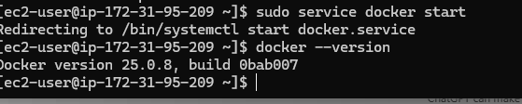

**Docker images:**

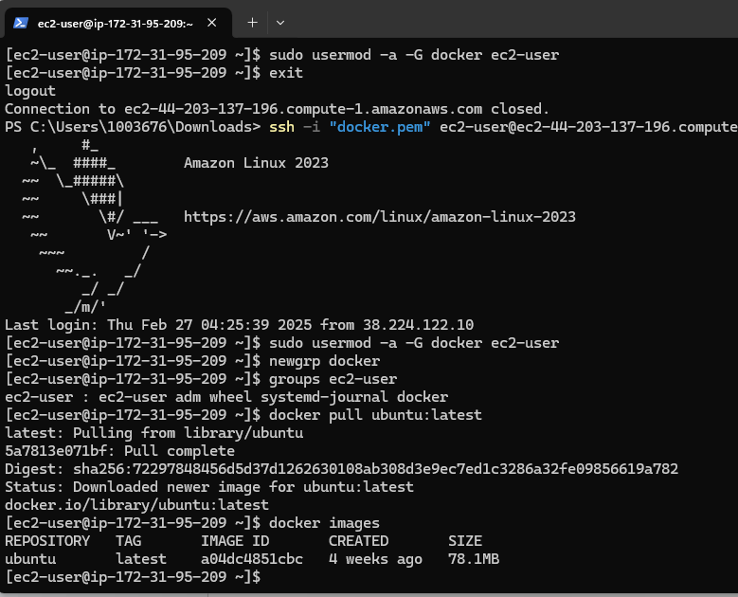

**Docker container status**

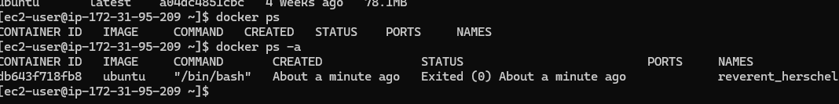

**Docker Volume**

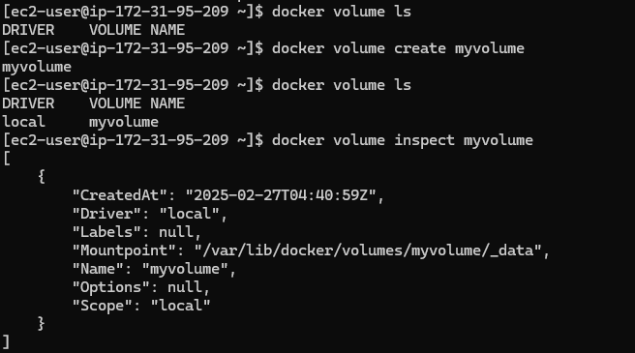

**Docker network**

